

You can contact YCARES at

yamhillcountyares@gmail.com

For more information about YCARES, please visit our web site at:

http://www.ycares.org

For more information about Yamhill County Emergency Management, please visit:

<http://www.co.yamhill.or.us/emergency-management>

Monthly Meeting:

4th Thursday of each month at the Lafayette Community Center in Lafayette. Meetings are from 7:00PM to 9:00PM

Weekly Ares Net:

Monday nights at 7:30PM

All Mondays, except the last Monday of the month, we will be on the YCARES repeater - at 441.800 (PL 100).

The last Monday of the month we will be on various local repeaters or simplex.

Where you can find YCARES

Serving the communications needs of Yamhill County.



Yamhill County

Amateur Radio

Emergency

Service

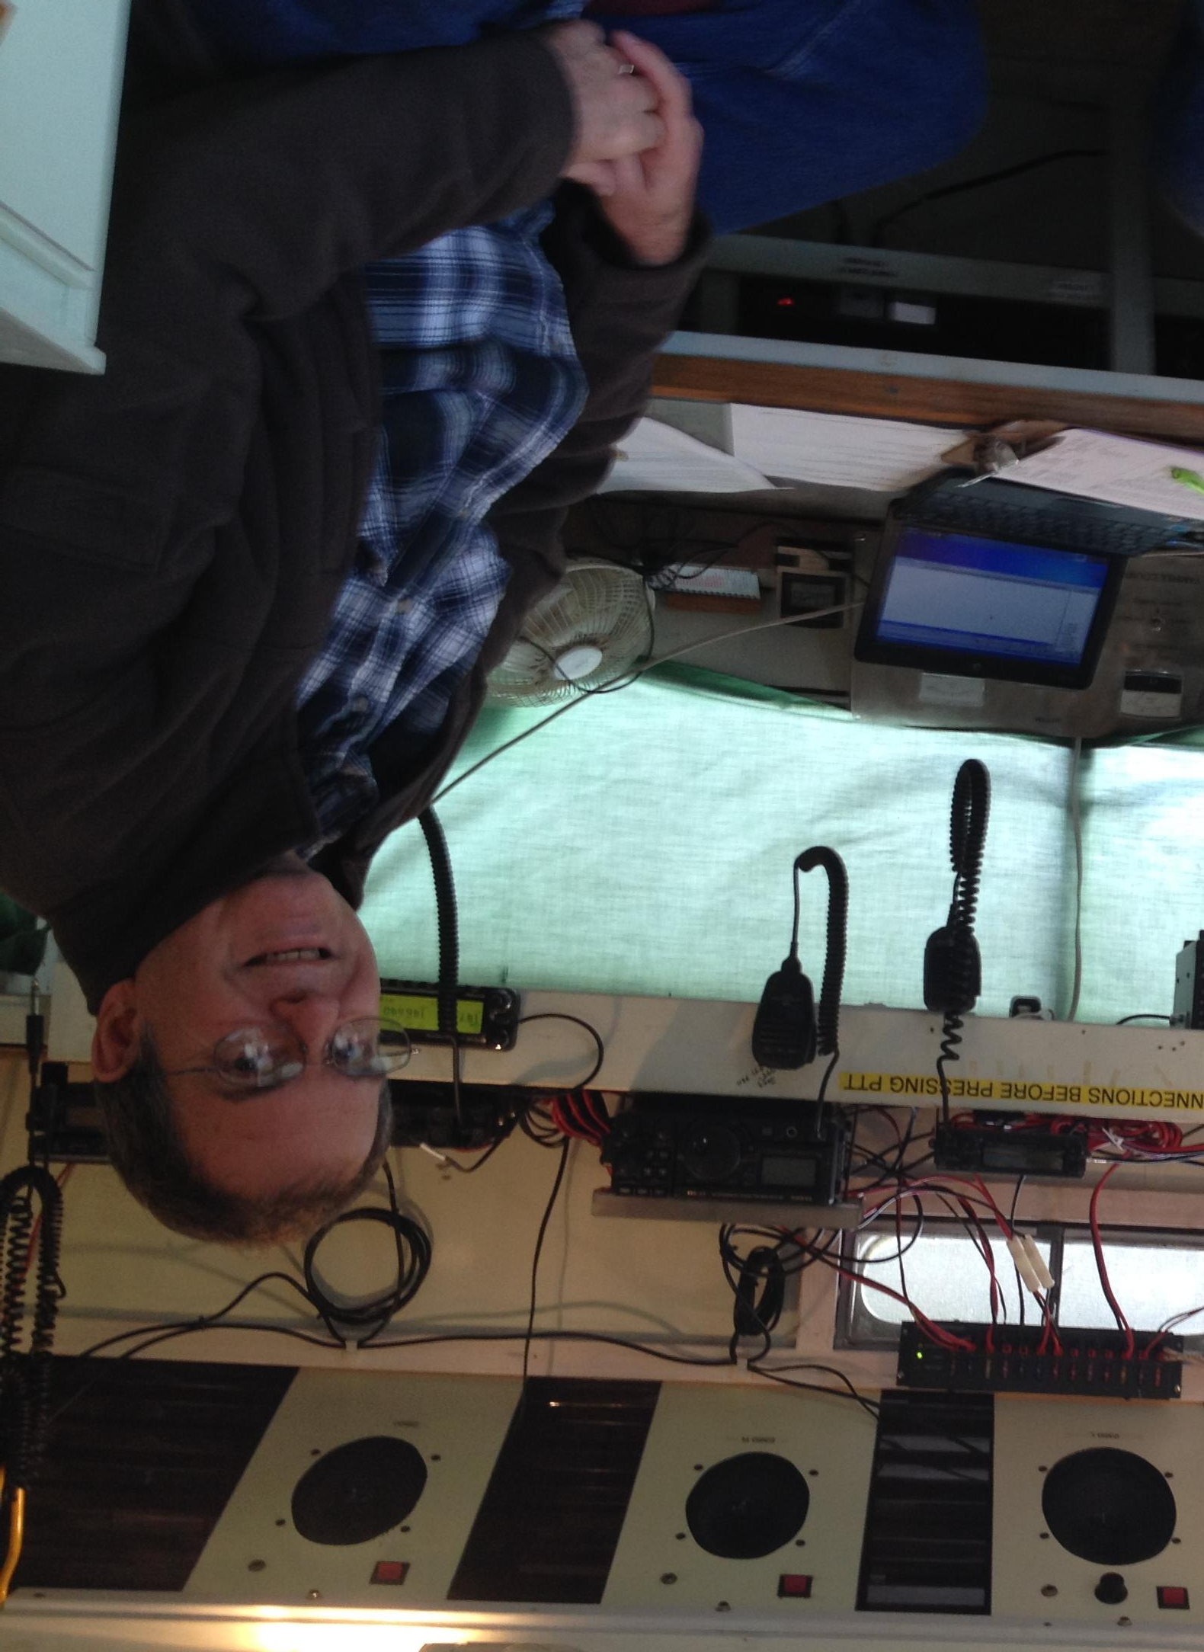

**Amateur Radio Emergency Service® (ARES)**

The Amateur Radio Emergency Service® (ARES) consists of licensed amateurs who have voluntarily registered their qualifications and equipment, with their local ARES leadership, for communications duty in the public service when disaster strikes. 

**ARES Membership Requirements**

Every licensed amateur, regardless of membership in ARRL or any other local or national organization is eligible to apply for membership in ARES.  Training may be required or desired to participate fully in ARES.  Please inquire at the local level for specific information.  Because ARES is an Amateur Radio program, only licensed radio amateurs are eligible for membership. The possession of emergency-powered equipment is desirable, but is not a requirement for membership.

**How to Get Involved in ARES**

Fill out the ARES Registration form and submit it to your local Emergency Coordinator.

Yamhill County ARES Requirements

* Amateur Radio License

Complete the following FEMA On-Line study courses:

• IS 100.b

• IS 200.b

• IS 700.a

• IS 800.b (Not required, but recommended)

What do we do?

* **Public Service Events**:  
  + Walk-a-thons, bike-a-thons, parades, festivals and community events.
  + Time commitment is typically defined in advance.
  + Equipment is minimal; often you will only be asked to bring a hand-held radio.
  + Responsibilities may include supporting the communications needs of the community agency  such as crowd control efforts, first aid stations, parking, etc.
* **Localized Disaster**:  
  + Flooding, tornados, or any substantial weather event, where it might not disrupt major areas of communications, but there is still a need for communications to be set up
  + Search, rescue, and traffic needs during the local disaster.
  + Time commitment is less than a major disaster
  + Typically the volunteer would be part of an organization. The organization would have a pre-planned list of expectations and roles.
* **Major Disaster**:
  + Wide-spread weather events, such as hurricane, tornados, snow storms, earthquakes.
  + A longer time commitment--several weeks to a few months.
  + Volunteers need to prepare their families for their absences.
  + In addition to personal Go Kits, volunteers may also need to bring their long-term Deployment Kits.

Yamhill County Amateur Radio Emergency Services has the following resources:

* Fully equipped radio station located at the Yamhill County Emergency Management office. Equipment includes VHF/UHF dual band radio, HF radio with auto tuner, computer capable of Winlink transmissions.
* 15 foot trailer with VHF/UHF dual band radio, HF radio with auto tuner, computer capable of Winlink transmissions.
* 3 jump kits (pictured above) for use throughout the county.
* Each city within Yamhill County will be equipped with a VHF/UHF antenna for YCARES use.

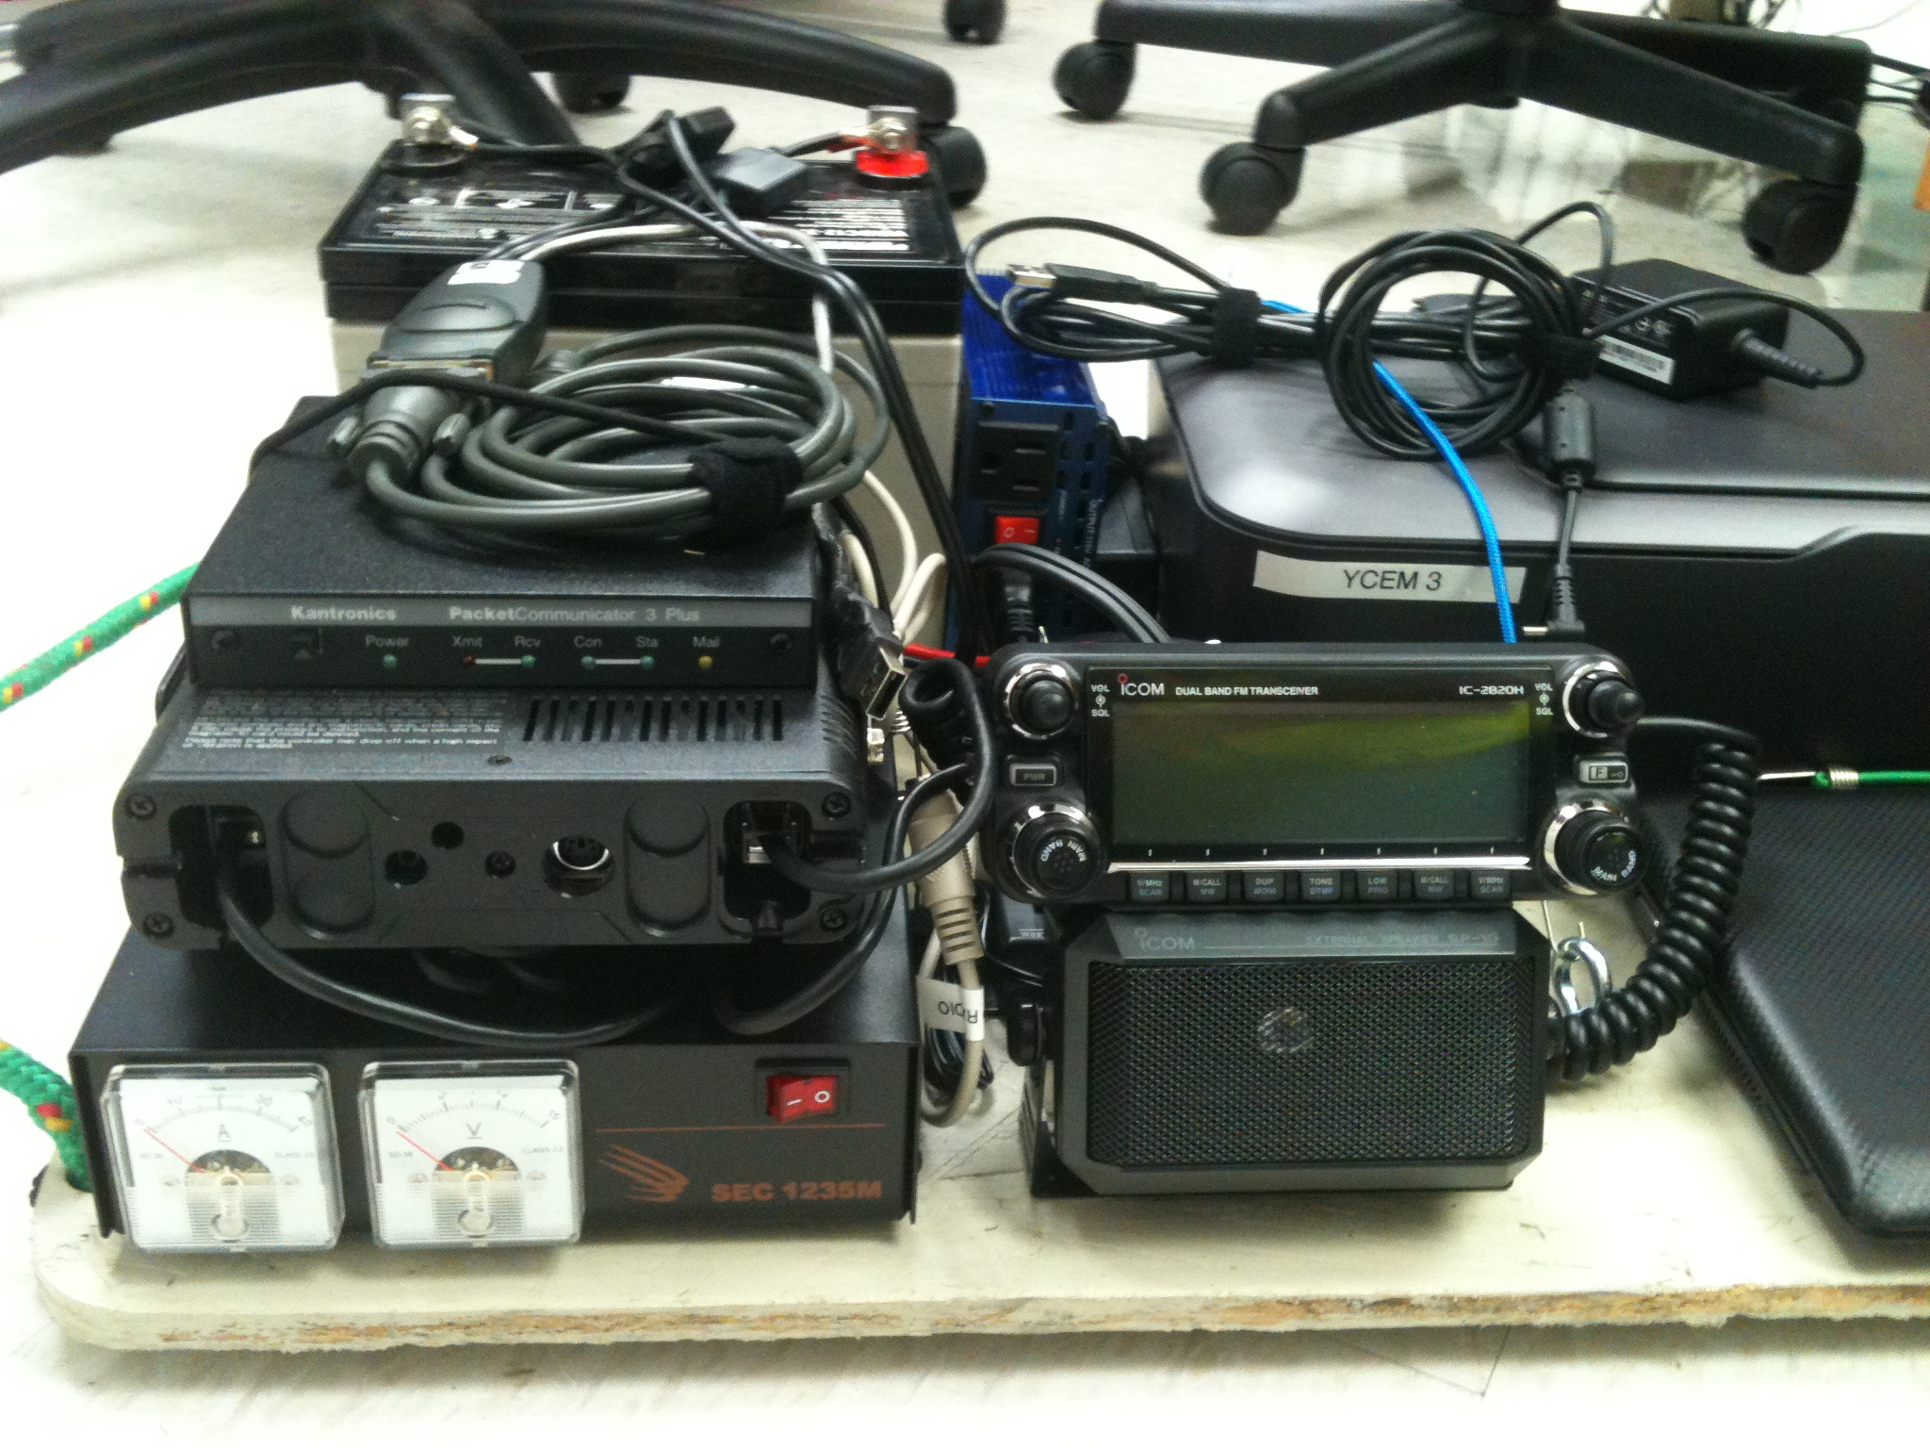

What is ARES?

YCARES Resources